NAME : K.Yamini Joshna

REGISTER NUMBER : 192110710

COURSE CODE : CSA0520

COURSE NAME : DATABASE MANAGEMENT FOR DATA ANALYTICS

##### Questions:

**WHERE:**

1. The student counsellor wanted to display the registration number, student name and date of birth for all the students.
2. The controller of examinations wanted to list all the female students
3. Who are the boy students registered for course with the course number “C001“
4. Display all faculty details joined before “November 2014”
5. Display all the courses not allotted to halls

##### LIKE:

1. List the students whose name ends with the substring “ma”
2. Display all students whose name contains the substring “ma”
3. Find all the students who are located in cities having “Sal” as substring
4. Display the students whose names do not contain six letters.
5. Find all the students whose names contains “th”

##### OUTPUTS:

1)

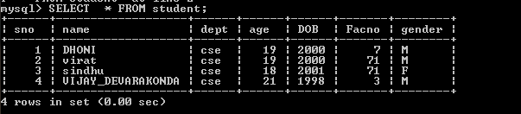

2)

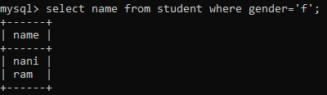

3)

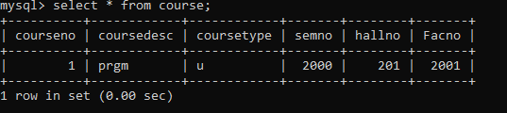

4)



5)

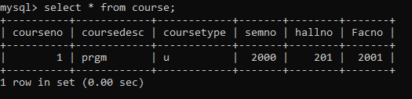

6)



7)



8)



9)



10)

